IN A NUTSHELL
- Pick 3 Lottery
- predict/wage for 3 digit combination to be drawn (ex. 618 for 1$ ticket)
- there are 2 separate draws per day (Midday-Evening).
You can win 2 ways:
- BOXED wins = predict for 3 digit combination to be drawn in ANY order- ex. 618 and winner is any of 618,816,168 etc. = EASIER = LOWER PAYOUT
- STRAIGHT wins = predict for 3 digit combination to hit in EXACT order - predict for 723 and winning draw 723 = HIGHER PAYOUT
Combinations Types – * I disregard triples (extremely rare)
- Singles ( 123, 459, 256 etc.)
- Doubles (244, 733, 922 etc.)
Permutation Possibilities
Singles – 6 total (ex. 617-716-176-167-671-761)
Doubles – 3 total (ex. 344-443-434)
*VTRACS - to simplify every single number has mirror , think lottery ball, v-trac/mirror patterns VERY STRONG WITH PATTERN RECOGNITION in this system/methodology*
Definition: A system that groups numbers to reduce the total number of combinations by mapping digits to VTrac digits.
VTrac Mapping:
VTrac 1-- 0, 5
VTrac 2 --1, 6
VTrac 3-- 2, 7
VTrac 4 --3, 8
VTrac 5-- 4, 9
Application: Simplifies the analysis by grouping numbers, allowing for pattern recognition across different number sets.
VTRAC STRAIGHTS:
Each STRAIGHT combination/pattern has 8 total full mirror combination variations: ex.
v224 | 113, 118, 163, 168, 613, 618, 663, 668

We can use this pattern indicator to extract STRAIGHT hits from our string patterns = HIGH PAYOUT low expense ($900/1$ online) = ORDERED/STRAIGHT PATTERNS

VTRAC BOX TABLE: You can also use v-trac/mirror relations for boxed hits, here is a table to simplify v-trac relations in boxed form
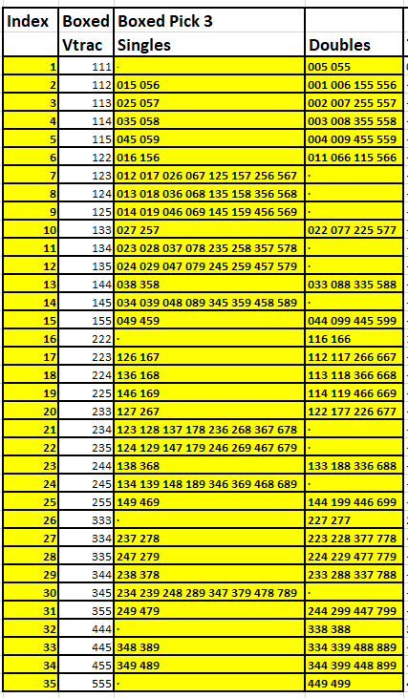
METHODS:
1) Pattern Progression /Stable Pattern Extraction 2) Digit Reduction Methods – via recent draw digits (will show in examples)
What we look for:
STABLE PATTERNS (boxed + straight)
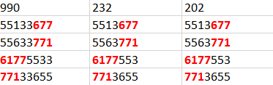
- 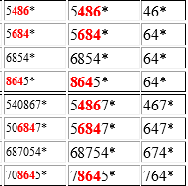

PERSISTANT STRAIGHT PATTERNS

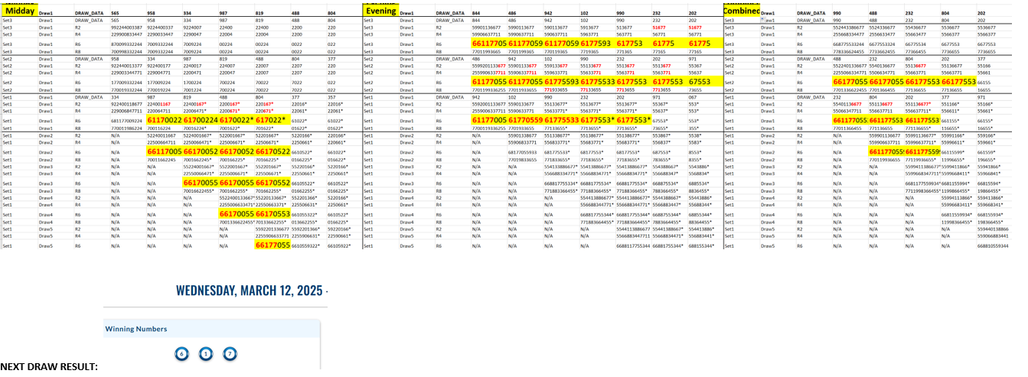

DATA:
Key Concepts:
• Pattern Progression: Both methods aim to identify patterns in the progression of strings as they are eliminated by draw data.
• Digit Transit: Observing how digits move and change across draws to identify potential winning combinations.
• Bayesian Influence: The idea that patterns can emerge from randomness, providing a statistical basis for predictions.

Each Column has 4 rows in Tables:
- **DRAW_DATA**: Original 3-digit numbers
- **R2**: 2000x pool size variations
- **R4**: 4000x pool size variations
- **R6**: 6000x pool size variations
- **R8**: 8000x pool size variations

💡 Important: R2/R4/R6/R8 are NOT progressively reduced sequences, but different arrangements of the same digits, we look for stable patterns within vertically and how pattern evolve and persist into adjacent R2/R4/R6/R8 boxes to the right.

- Digits are reduced across columns (by previous winning draw digits) and each column is a new R2/R4/R6/R8 box. A collection of boxes/columns form a total R2/R4/R6/R8 pattern progression structure/table.
- It is basically vertical pattern progression (R2/R4/R6/R8) and horizontal across columns.

QUICK VISUAL EXAMPLES – methods working consistent (**most recent draw digits under column 1)

ONE WEEK ONTARIO EXAMPLE

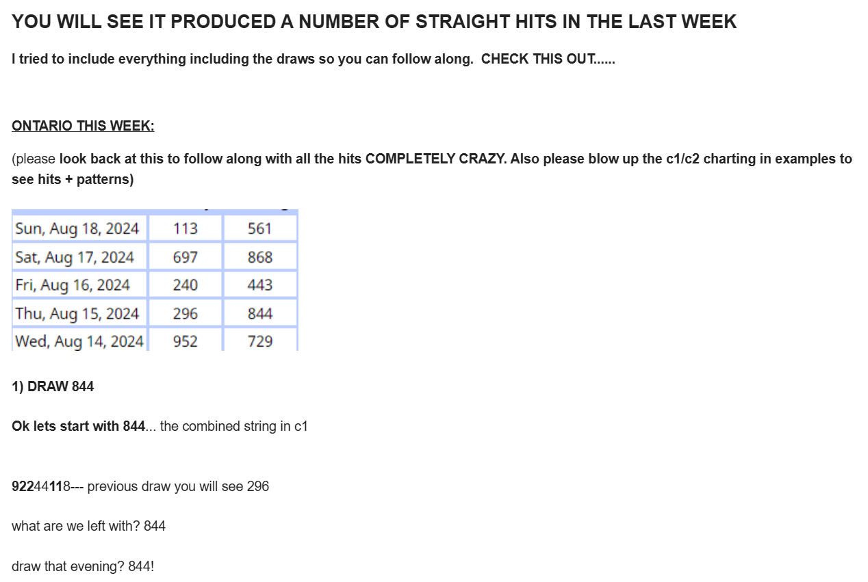

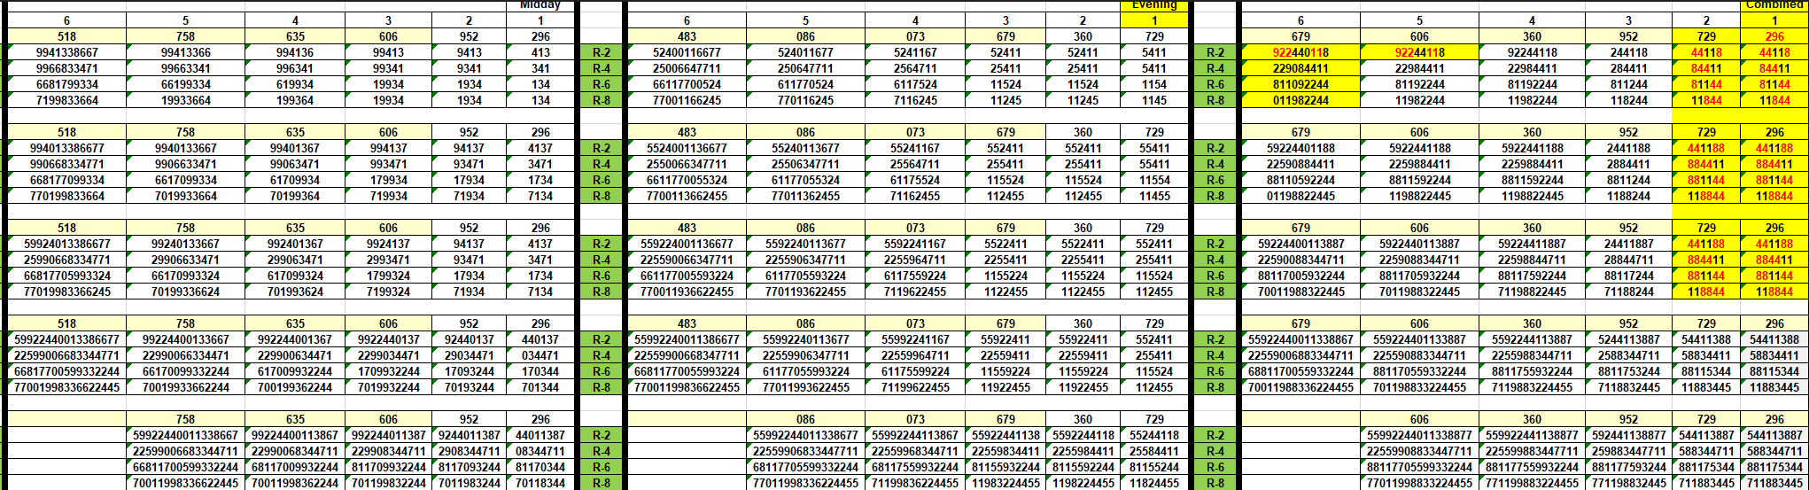

___________________________________________________________________________________________________________________________________________________________________
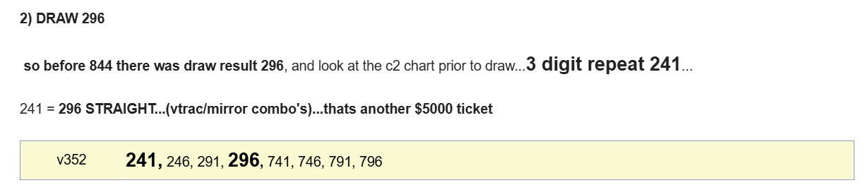

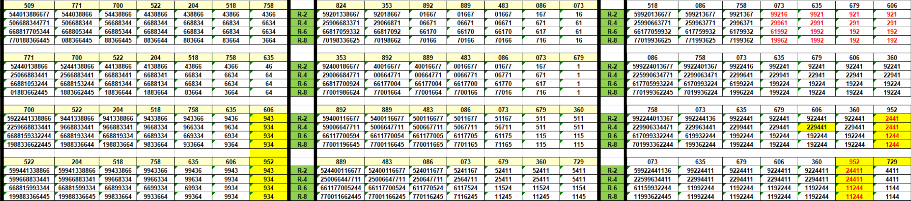

______________________________________________________________________________________________________________________________________________________________

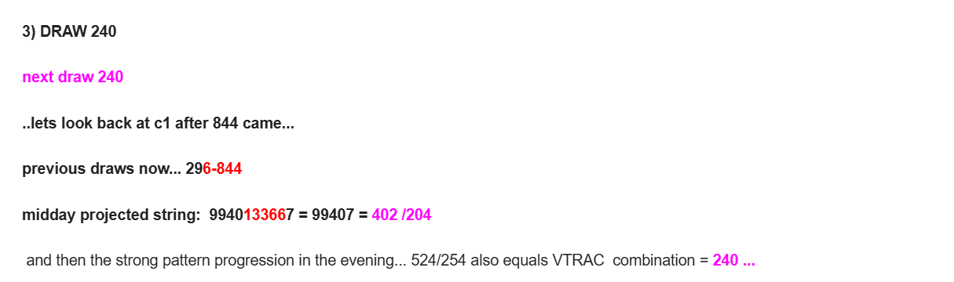

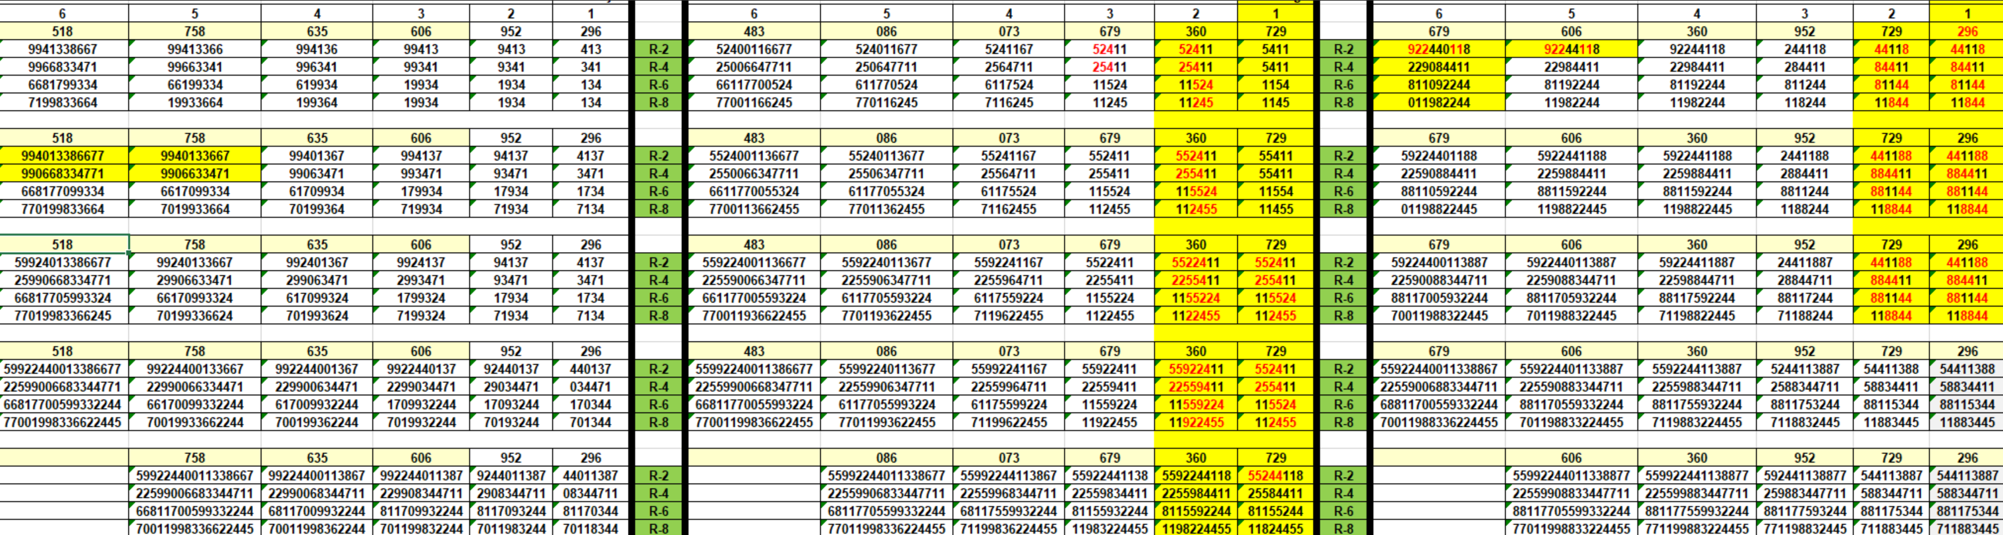

______________________________________________________________________________________________________________________________________________

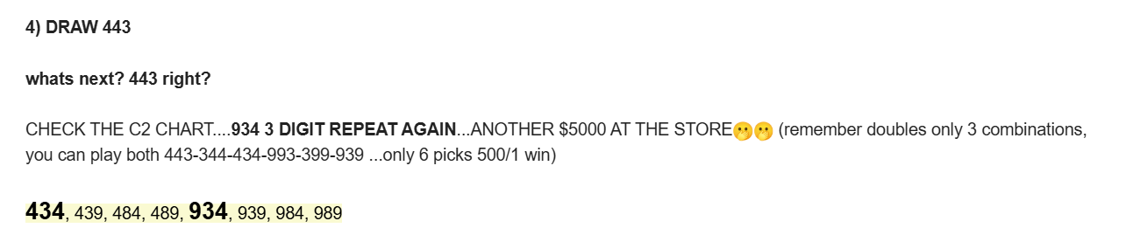

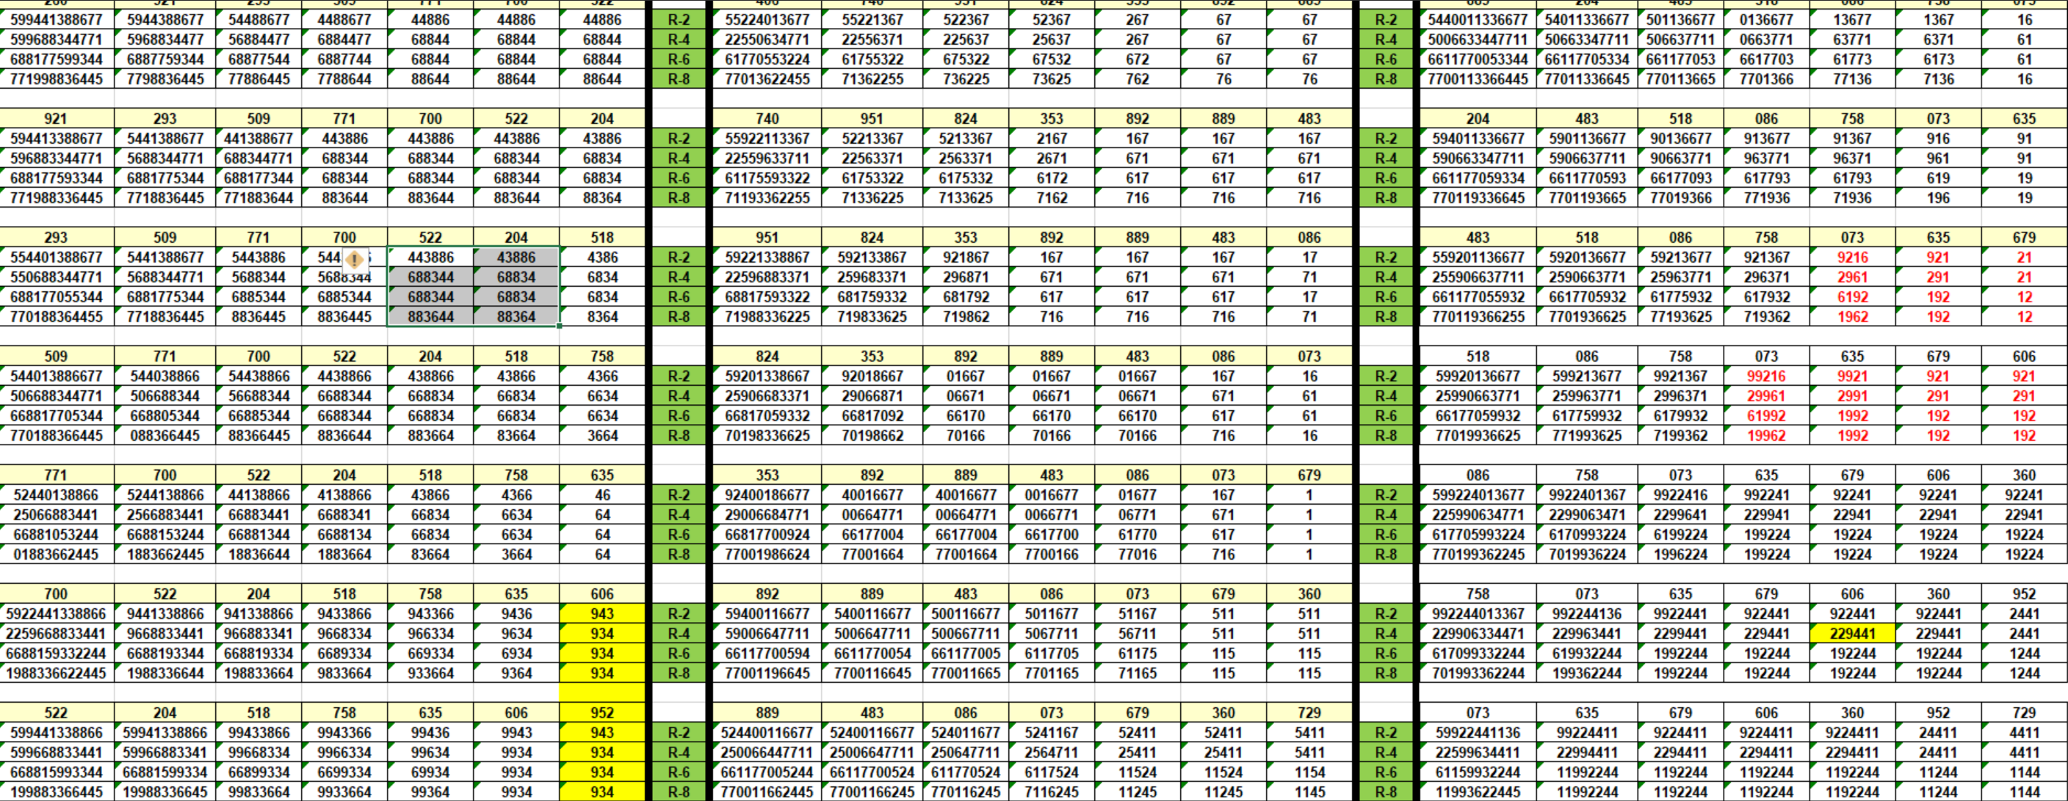

___________________________________________________________________________________________________________________________________________________________
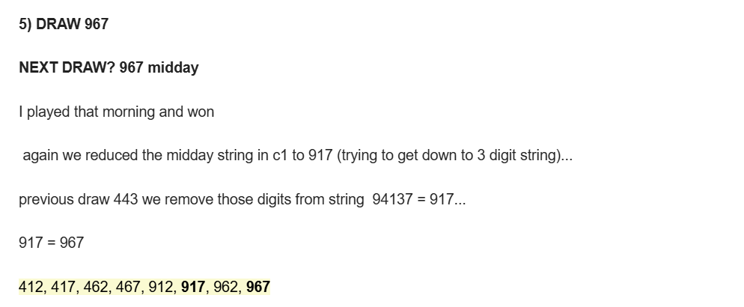

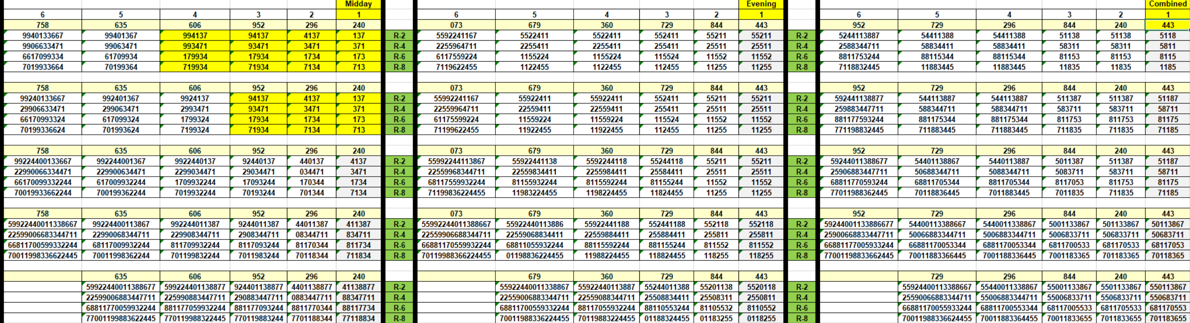

_______________________________________________________________________________________________________________________________
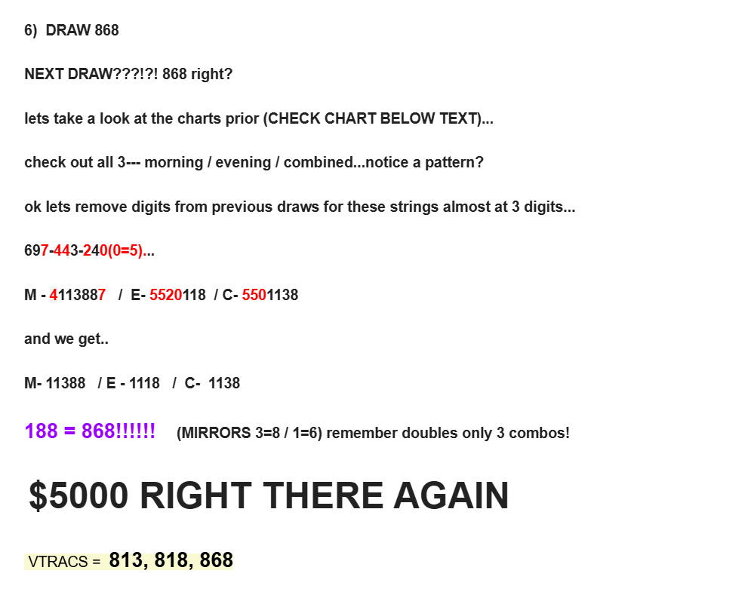

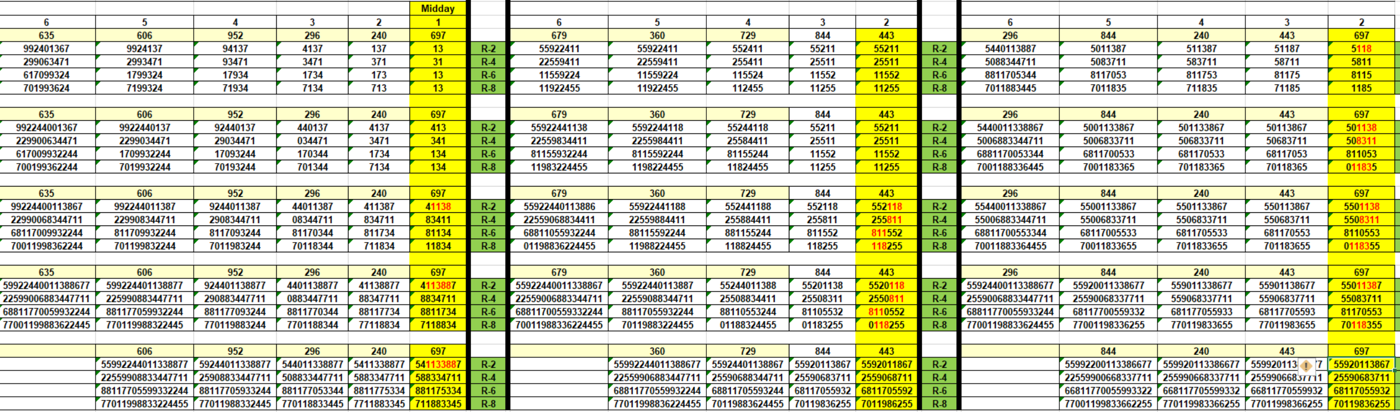

_____________________________________________________________________________________________________________________________________________________

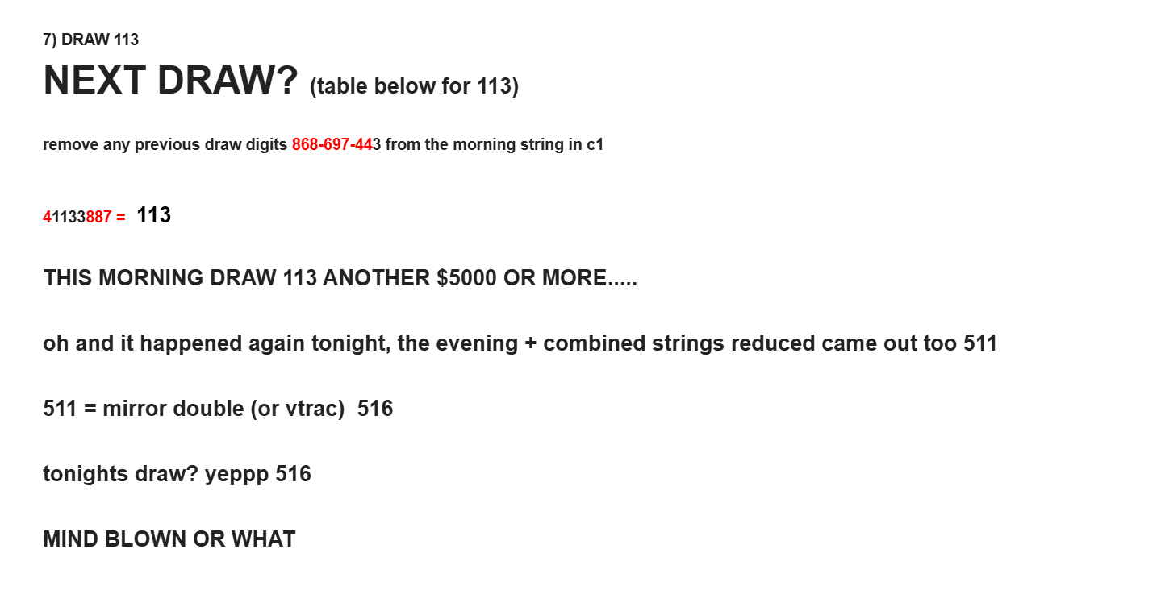
Look at both 113 and 516 winning numbers for that day based on reductions mentioned above….

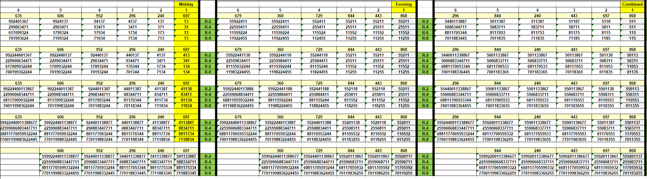

****USE THESE DRAWS TO FOLLOW BELOW….COPY AND PASTE IN DOCUMENT BESIDE YOU IF HELPFUL*****

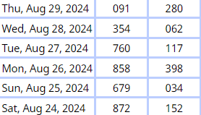

EXAMPLE 1: DATA PRIOR TO AUG 29TH DRAW

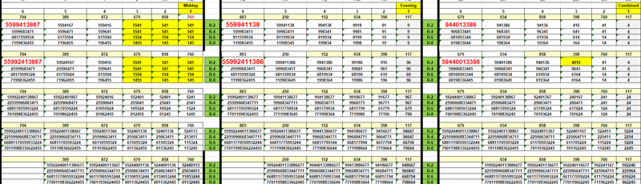
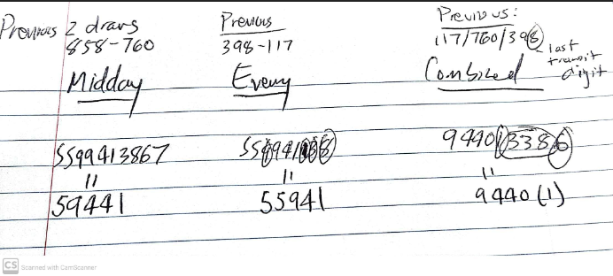
591 /541/401 = 091
and 541 repeat throughout Midday chart (left) 541 vtrac straight (8 combo's) = 091
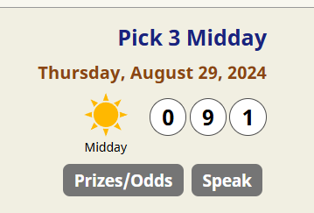

EVENING AND MIDDAY PRIOR TO DRAW AUG 28TH DRAWS

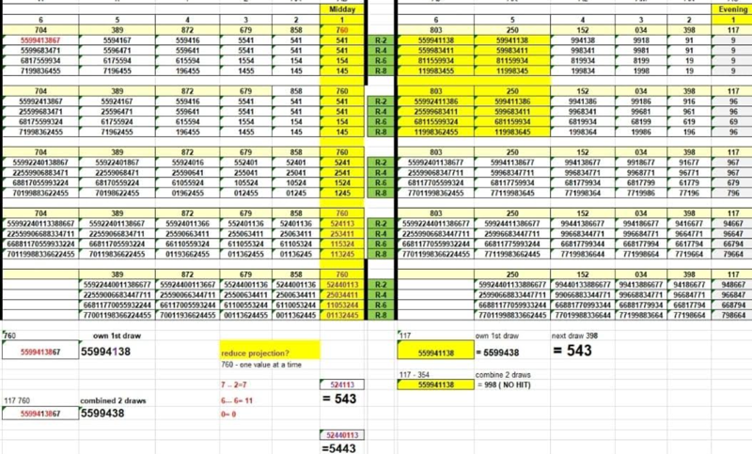


______________________________________________________________________________________________________________________________________________________

EXAMPLE 2: DATA PRIOR TO DRAW AUG 27TH:
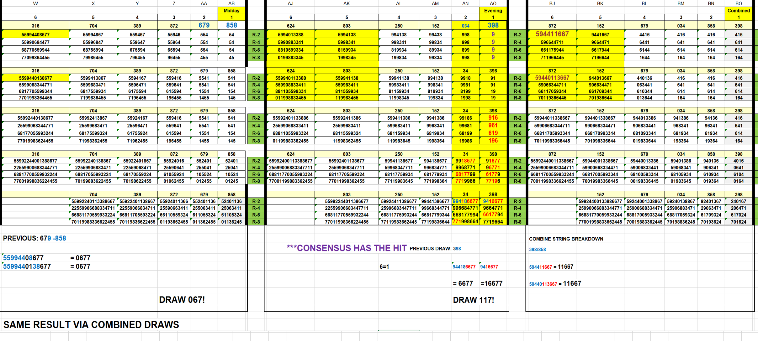

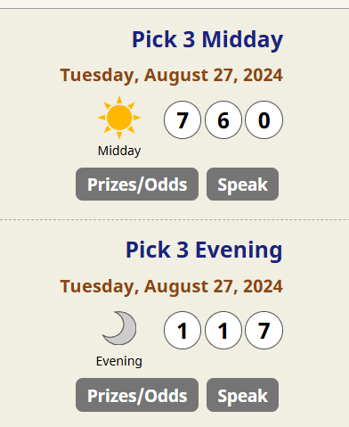

__________________________________________________________________________________________________________________________________________________________

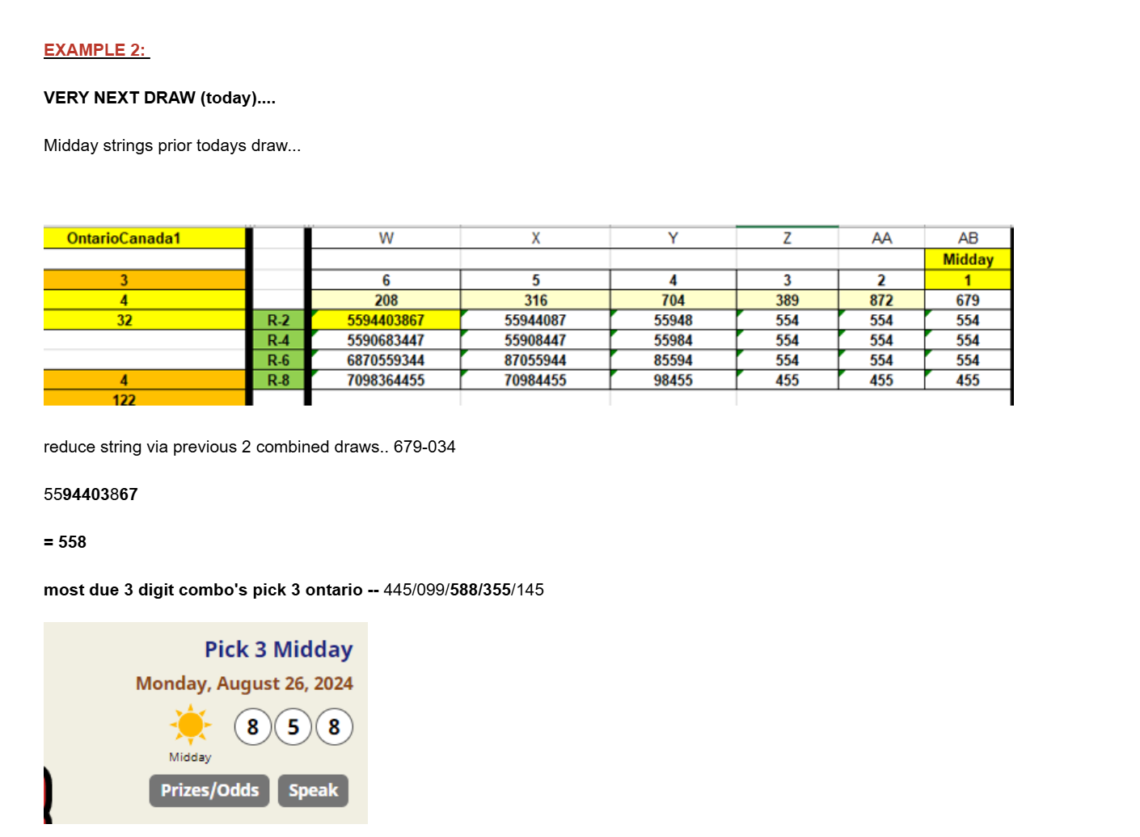

______________________________________________________________________________________________________________________________________________________________

EVENING STRINGS CHART PRIOR TO DRAW AUG 26th
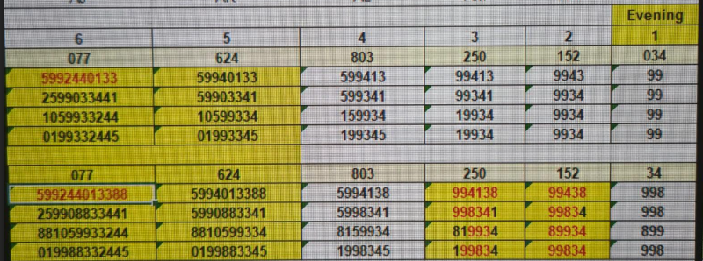
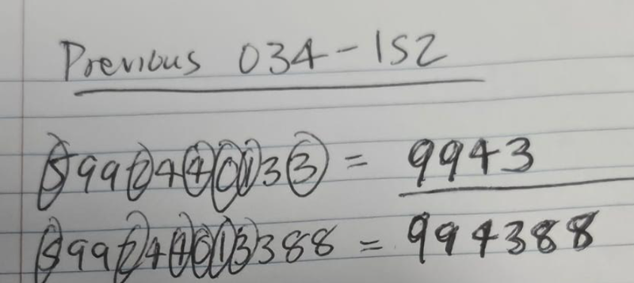
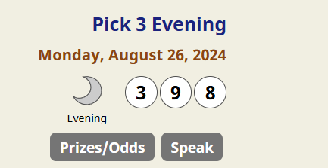

398

__________________________________________________________________________________________________________________________________________________

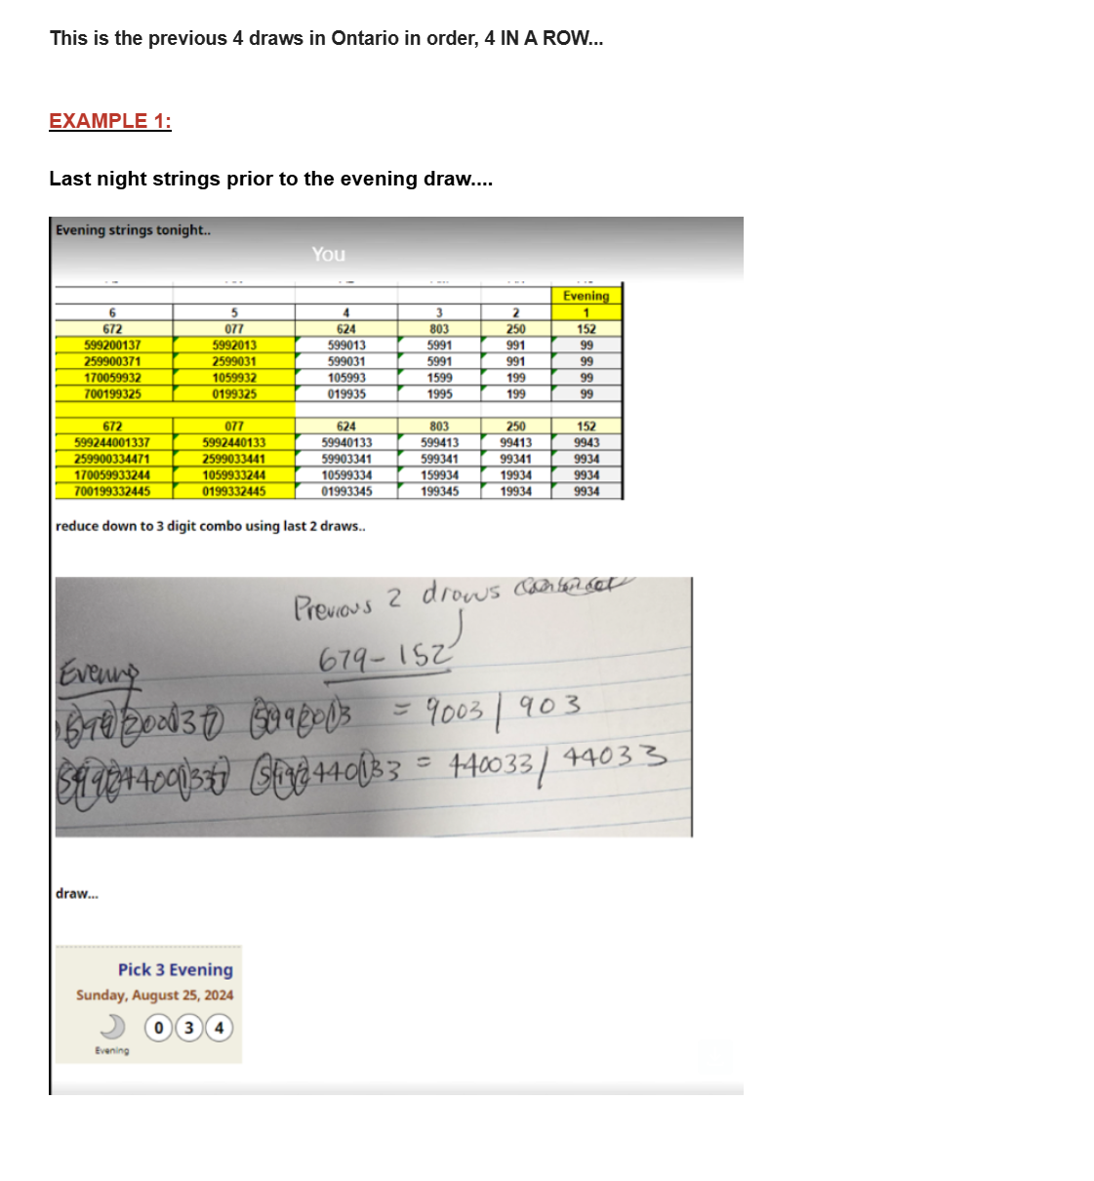

______________________________________________________________________________________________________________________________________________


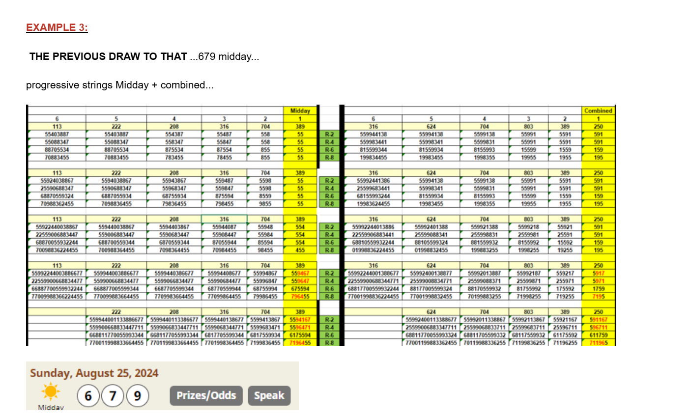

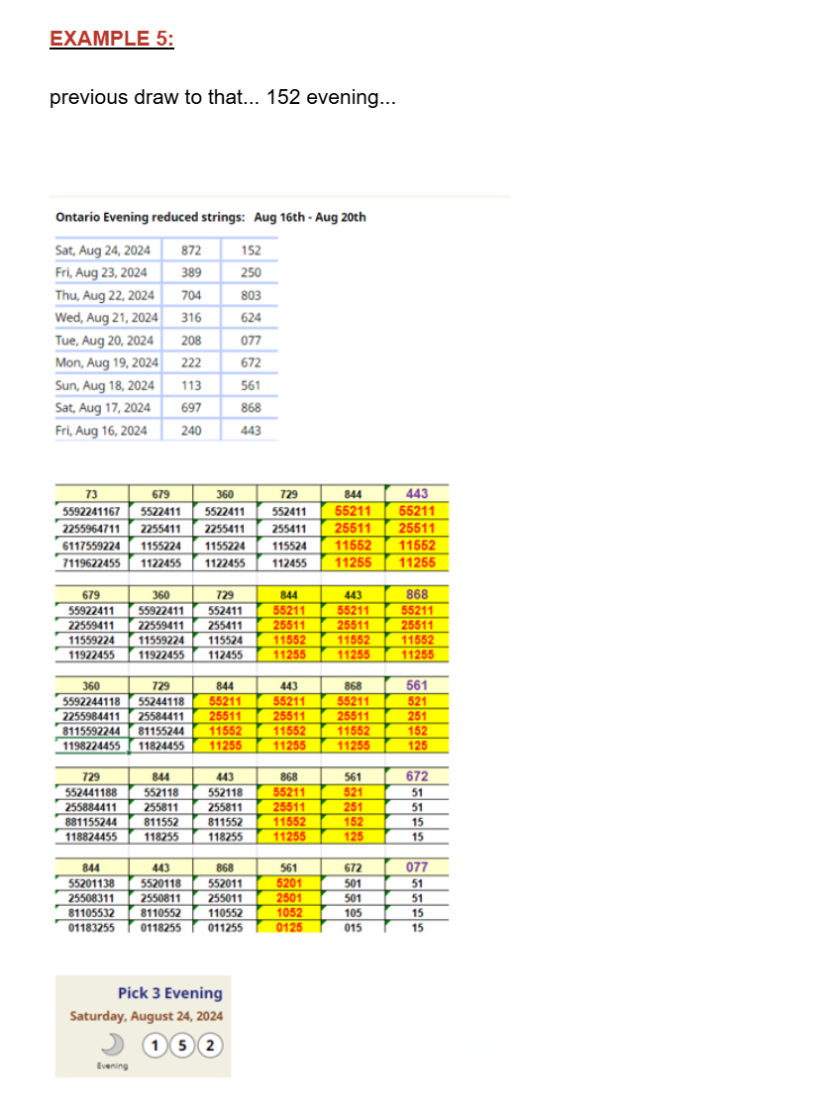

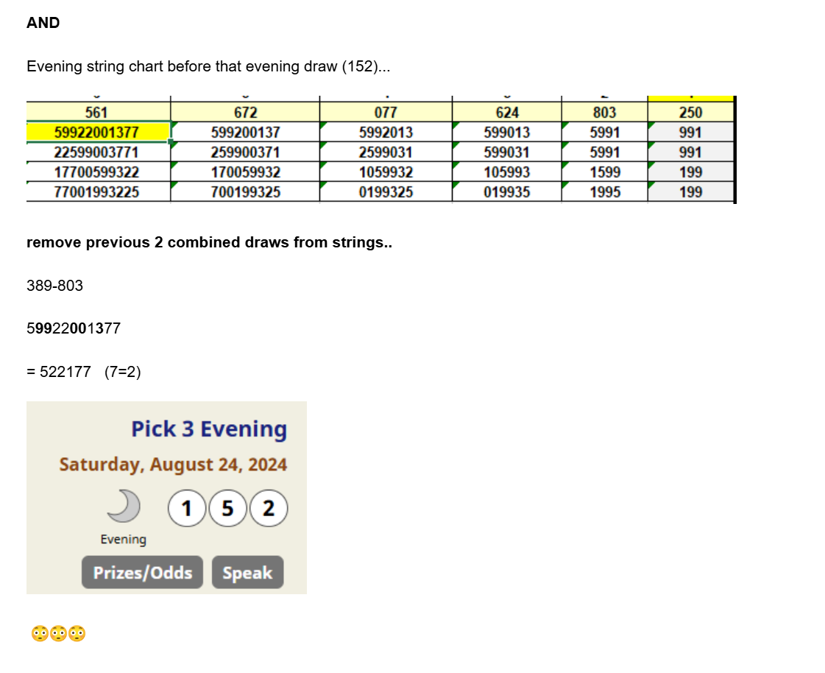

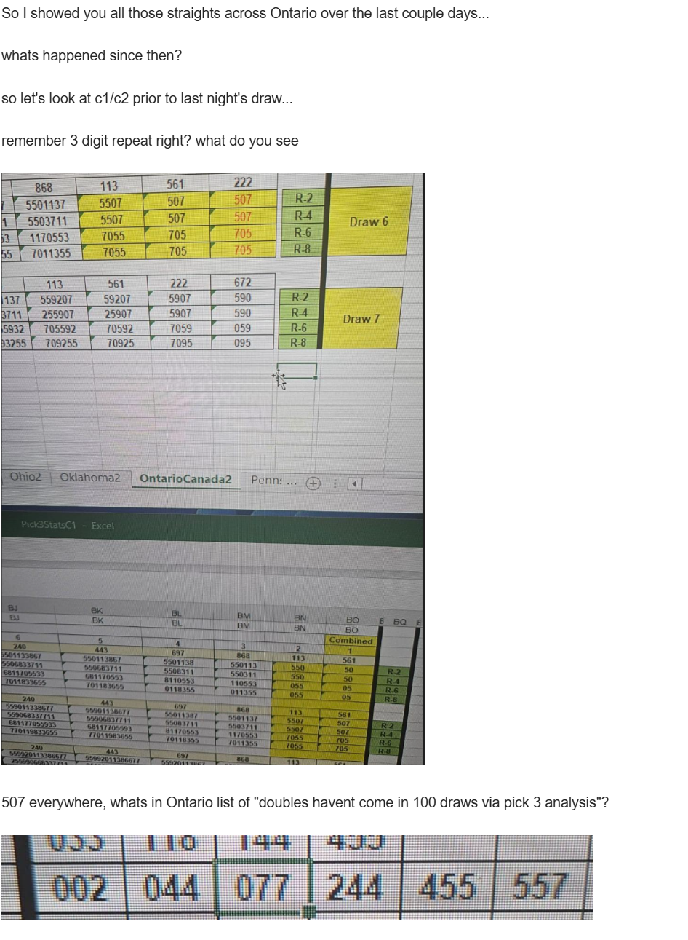

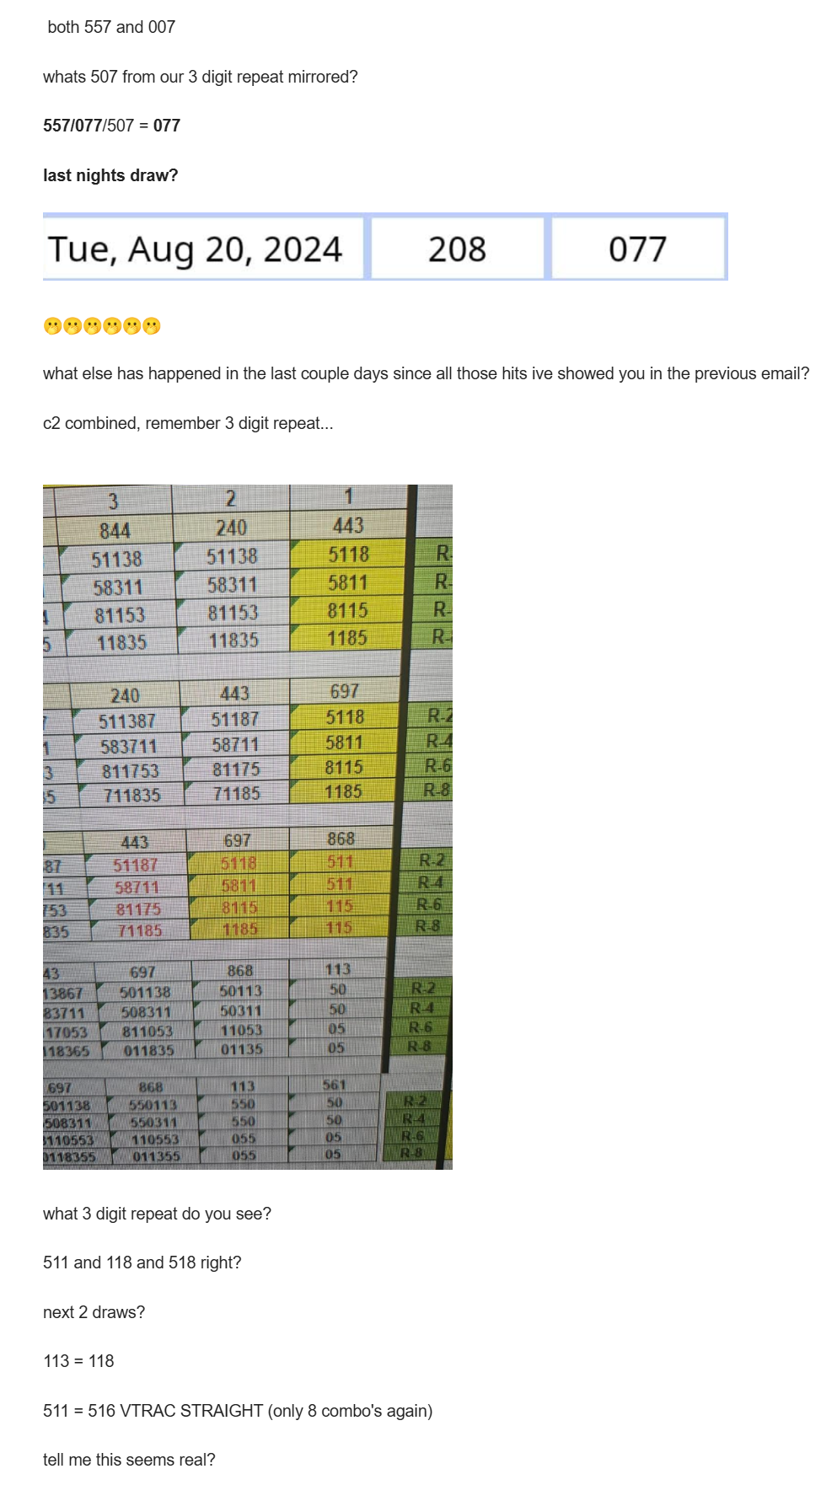

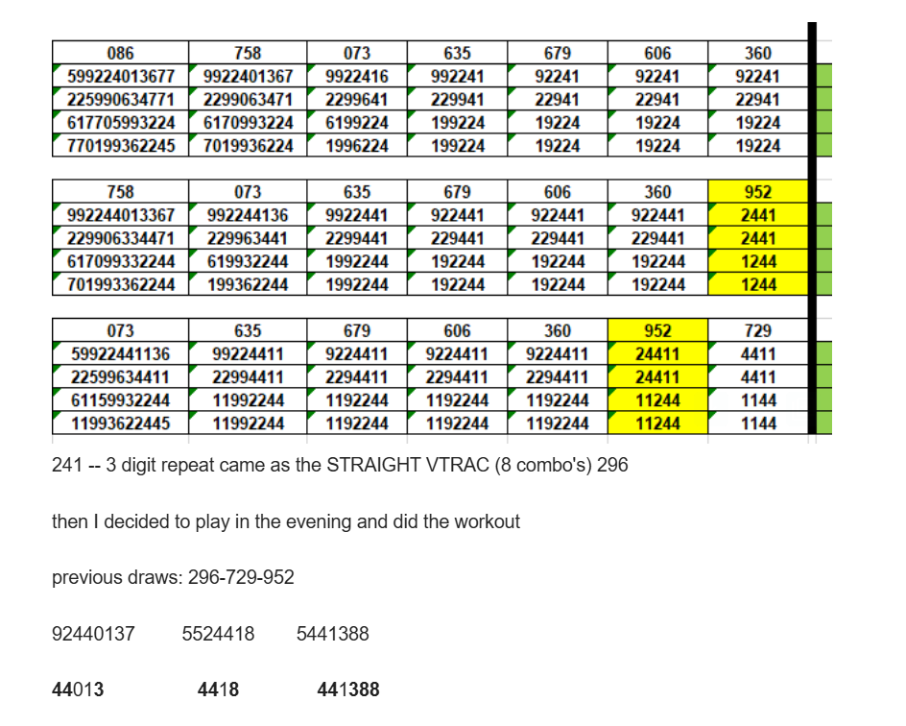

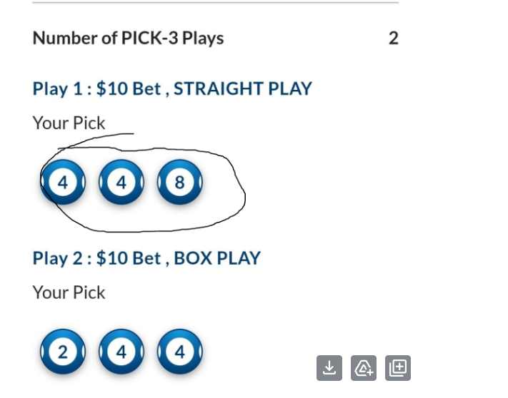

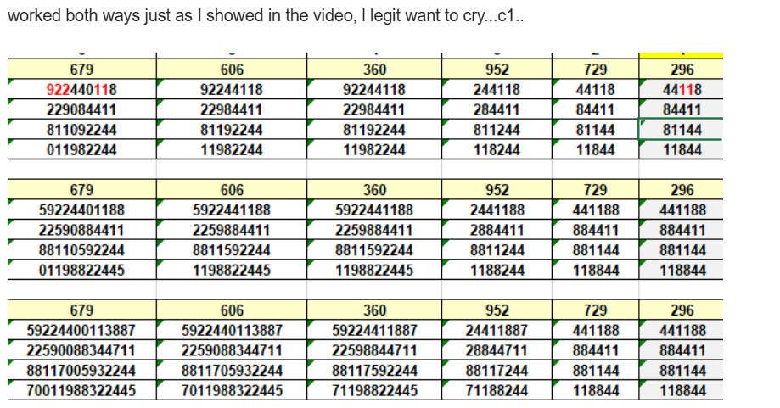

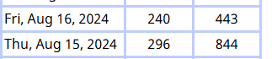
HOT ZONES
set 1 is current




